Quiz#9
Section: __________________________ Group: _______________________
Name(print): ______________________________ Student ID: _________________________
- Two bugs, Buzz and Crunchy, are standing on a rotating record disk as shown in the diagram below. Which of the following statements is correct?
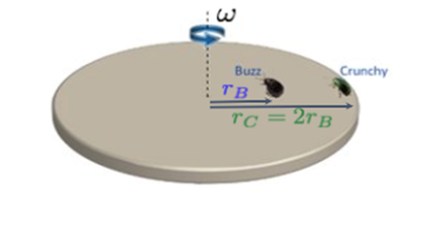
- They have the same angular speed.
- They have the same linear speed.
- They have the same kinetic energy.
- None of the above is correct.

The following questions are based on this situation: A girl is at a carnival riding a Merry-Go-Round that is rotating counterclockwise with an angular velocity of 3.2 rad/s. At a certain moment, the ride begins to slow down with a constant angular deceleration of 0.34 rad/s². The distance between the girl and the center of the Merry-Go-Round platform is 1.4 m.
- What are the girl's linear speed and angular speed after the ride has been slowing down for 3.5 seconds?

- From the moment the ride begins to slow down, what is the angular displacement of the girl before the Merry-Go-Round comes to a complete stop?

- Which of the following diagrams correctly show the directions of angular velocity and angular acceleration?


